1. Configure VPC peering in cross regions.

------ Launch 1 ec2 in N.virgina region

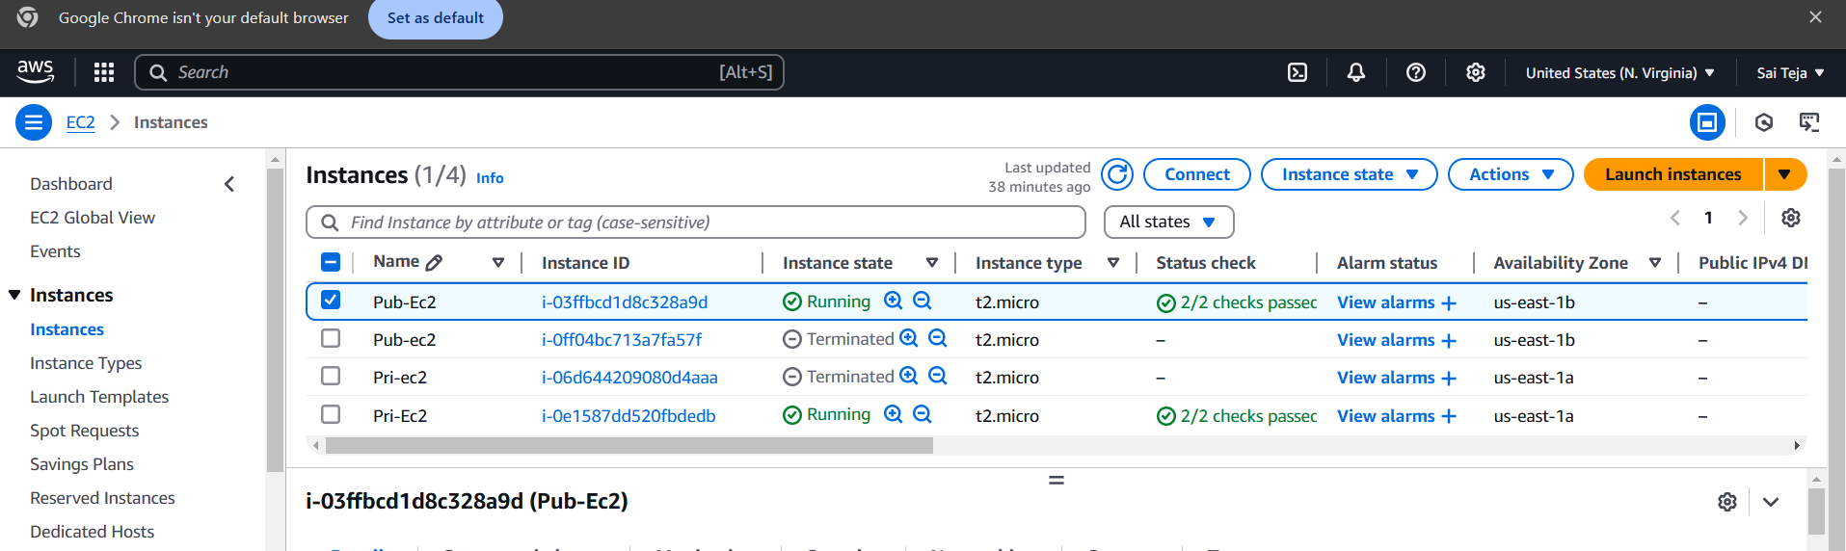

---launch another ec2 in ohio region

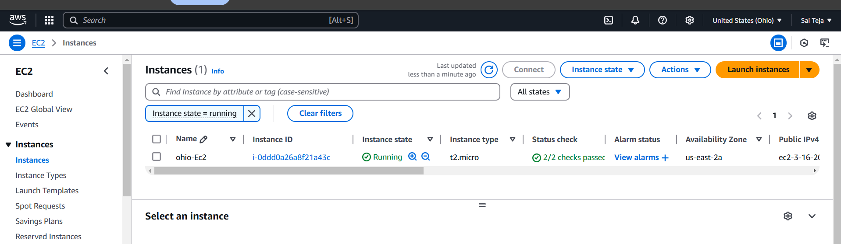

---- create peering connection B/w 2 different region vpc

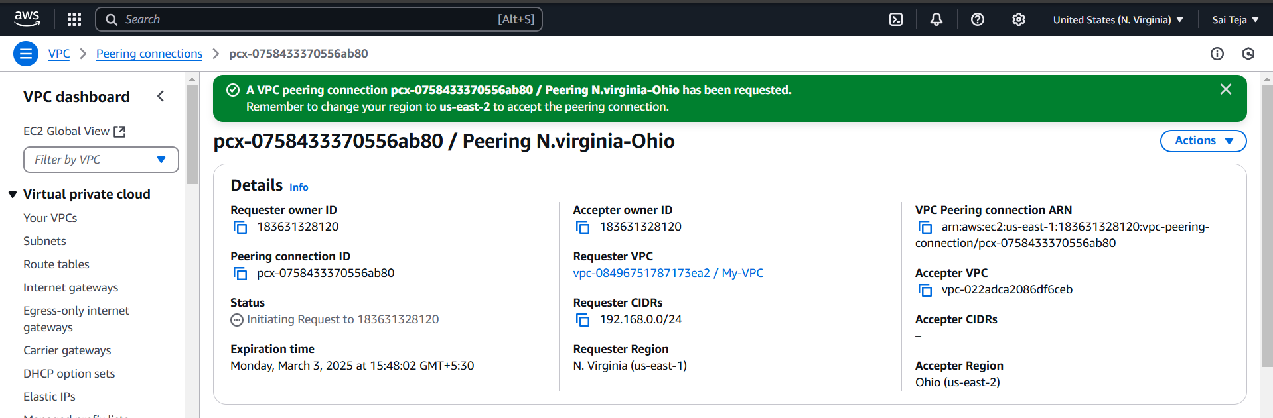

----- Accept the peering request from the ohio ec2

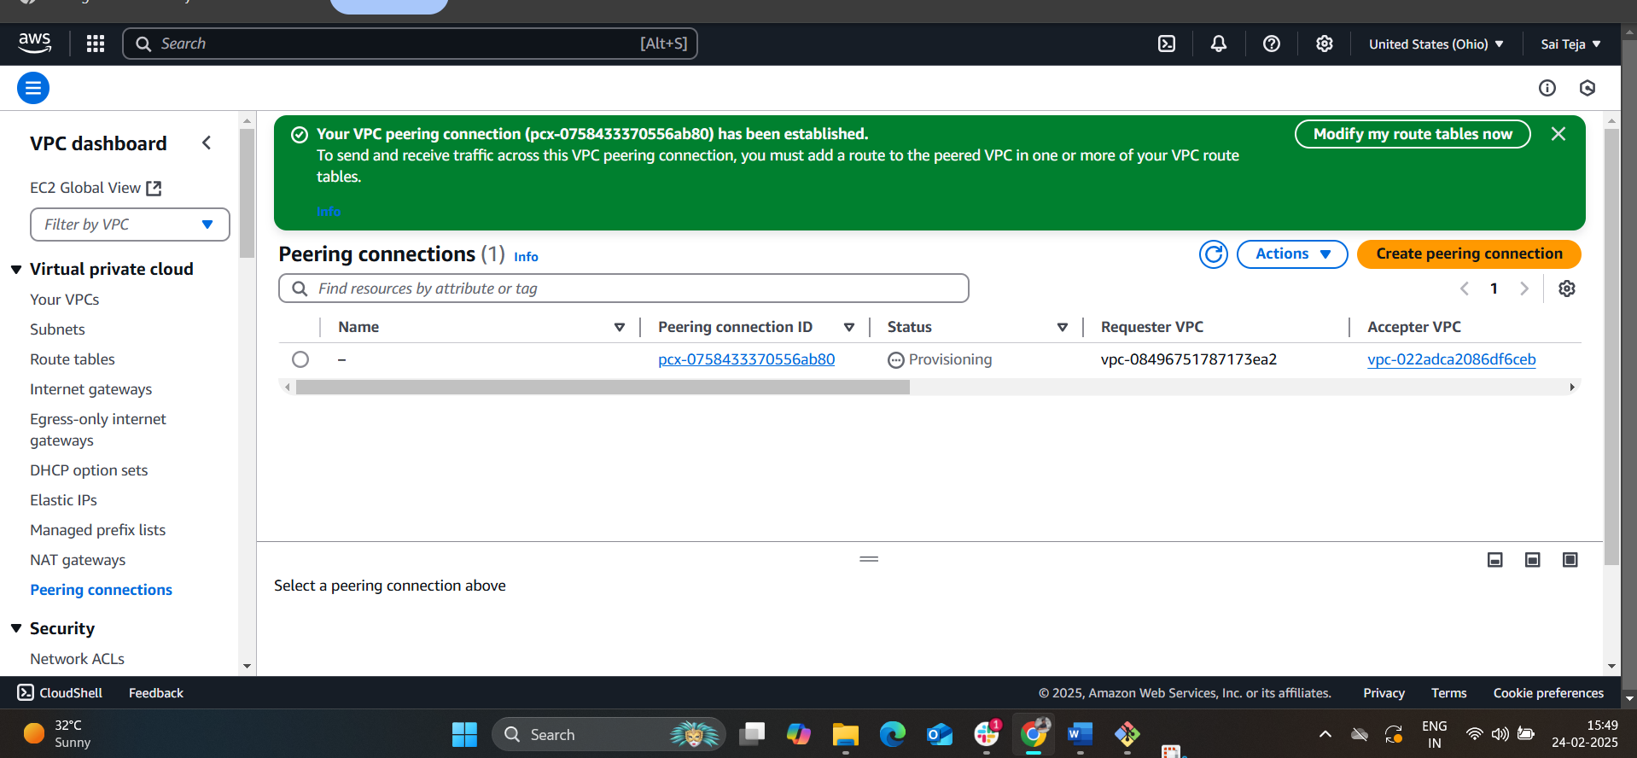

------ Copy the pri ID of ohio ec2 and ping that id from N.virgina ec2 from gitbash

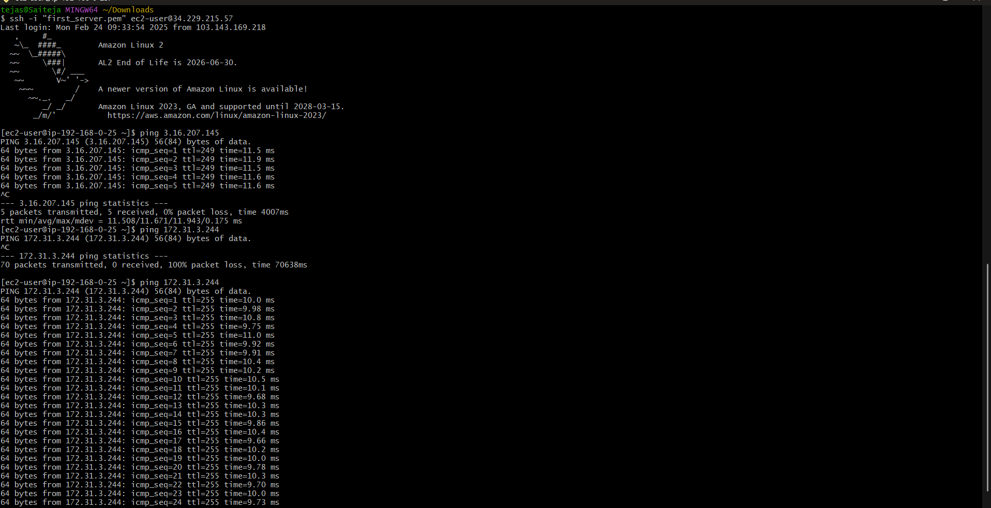

1. Purchase one domain from GoDaddy.

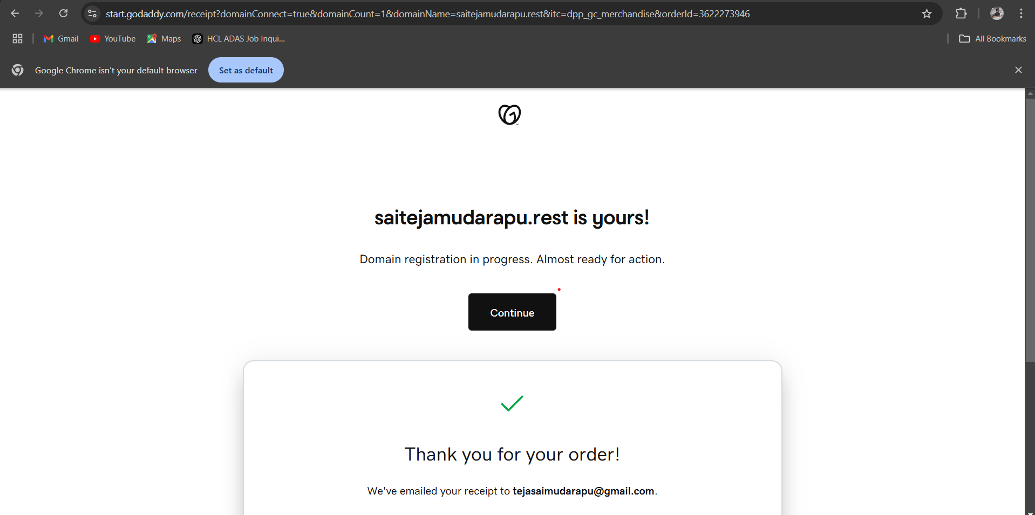

1. Deploy static website in s3

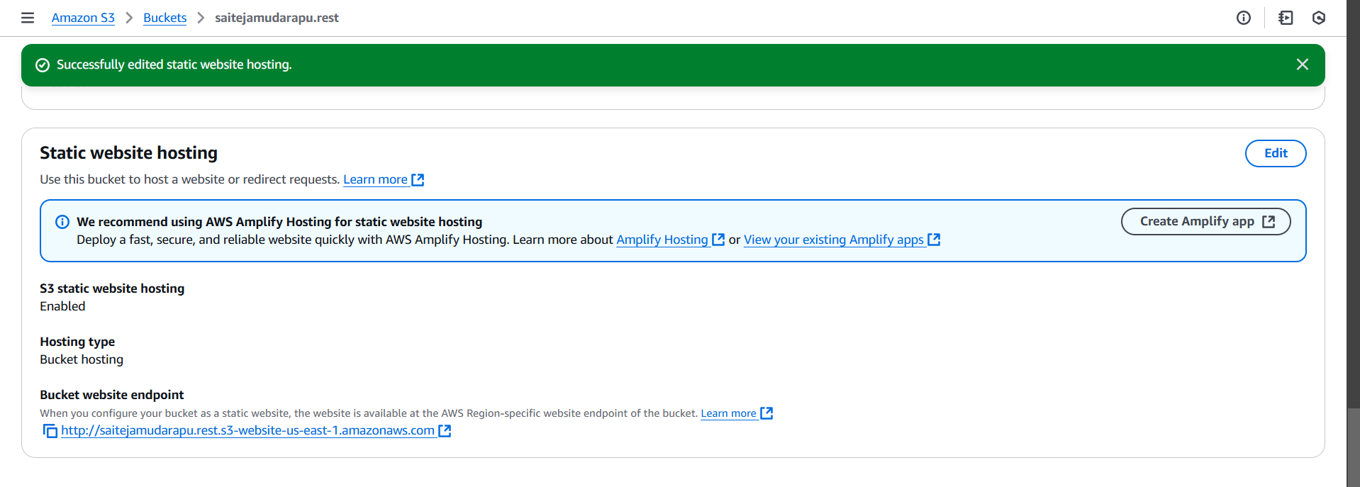

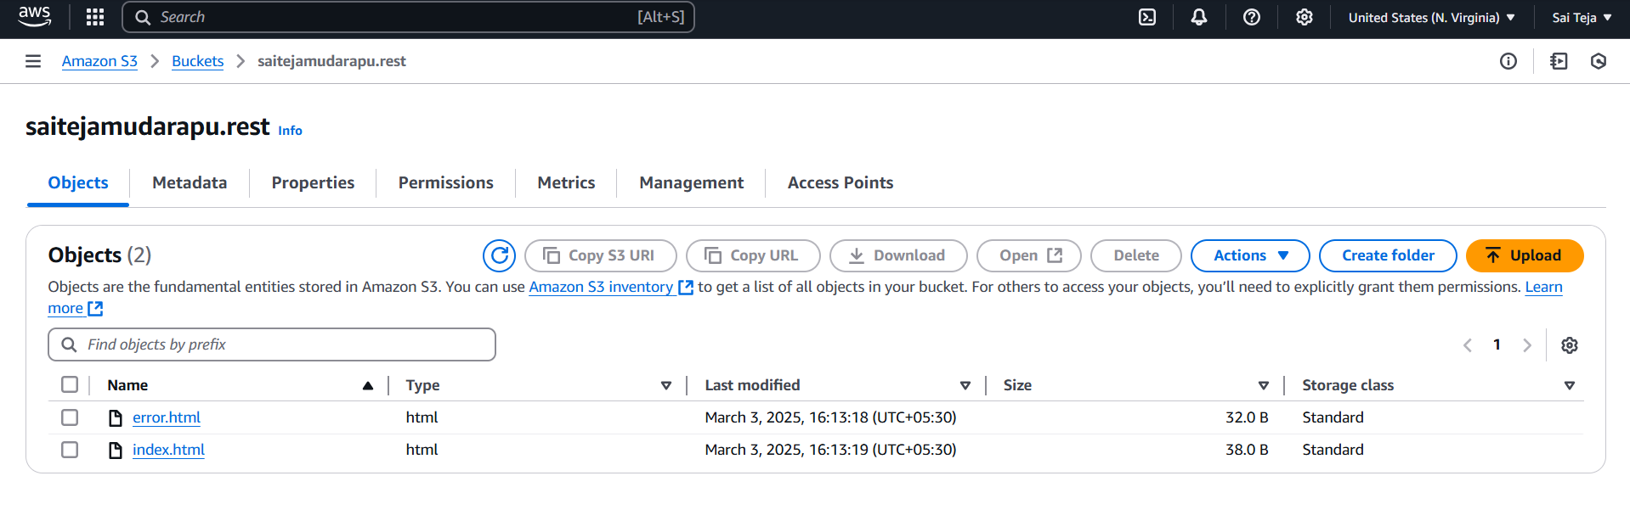

1. Create CDN and attach one SSL certificate.

------ go to cloud front and create distributions

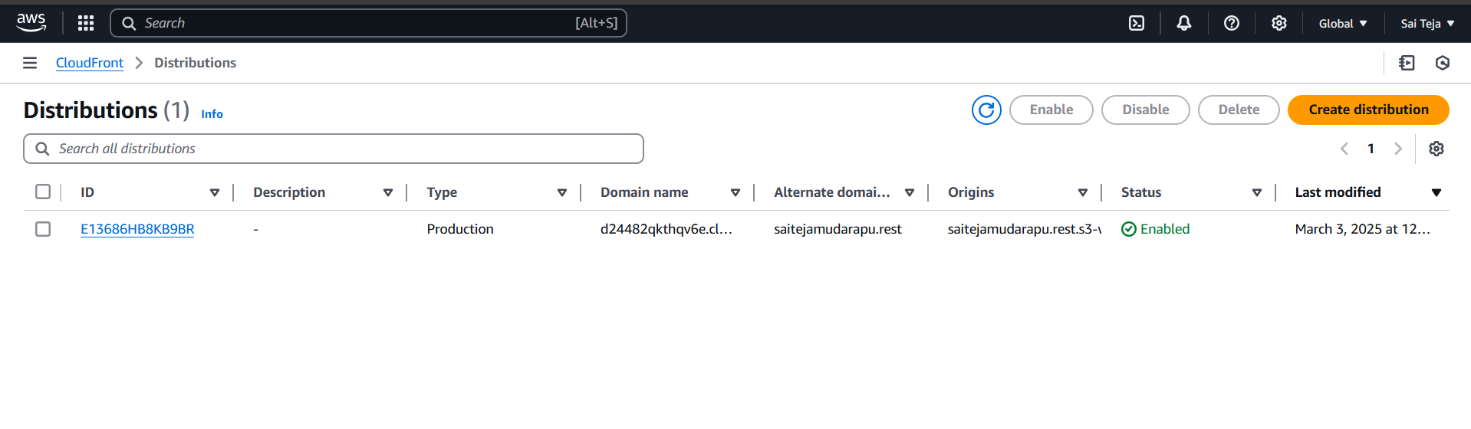

----- click on the created distributions click on edit and create on SSL certificate

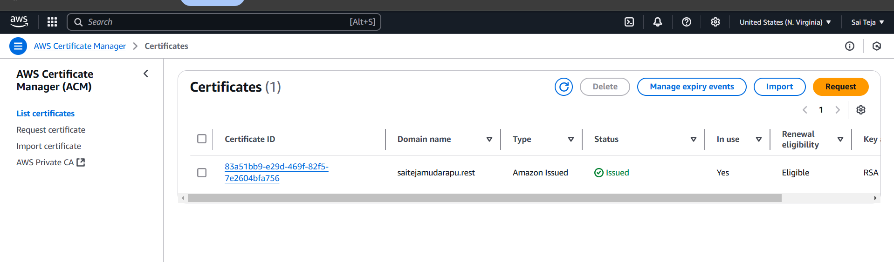

----click on the certificate id , need to create records in route 53 ,then only certificate will be issued

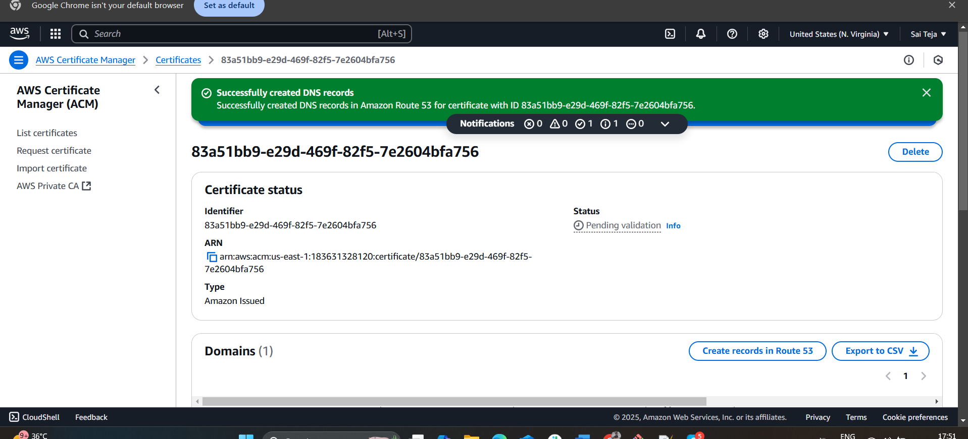

1. Create Route53 hosted zone and MAP the domain with CDN.

---- go to route 53 , we find hosted zone click on and create one hosted zone

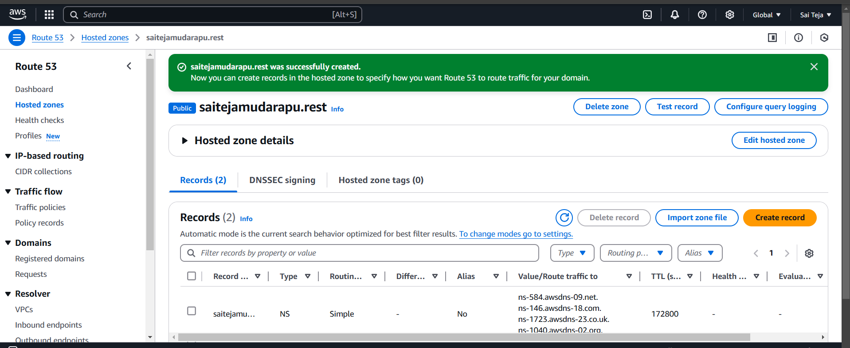

--- added NS to the created Domain

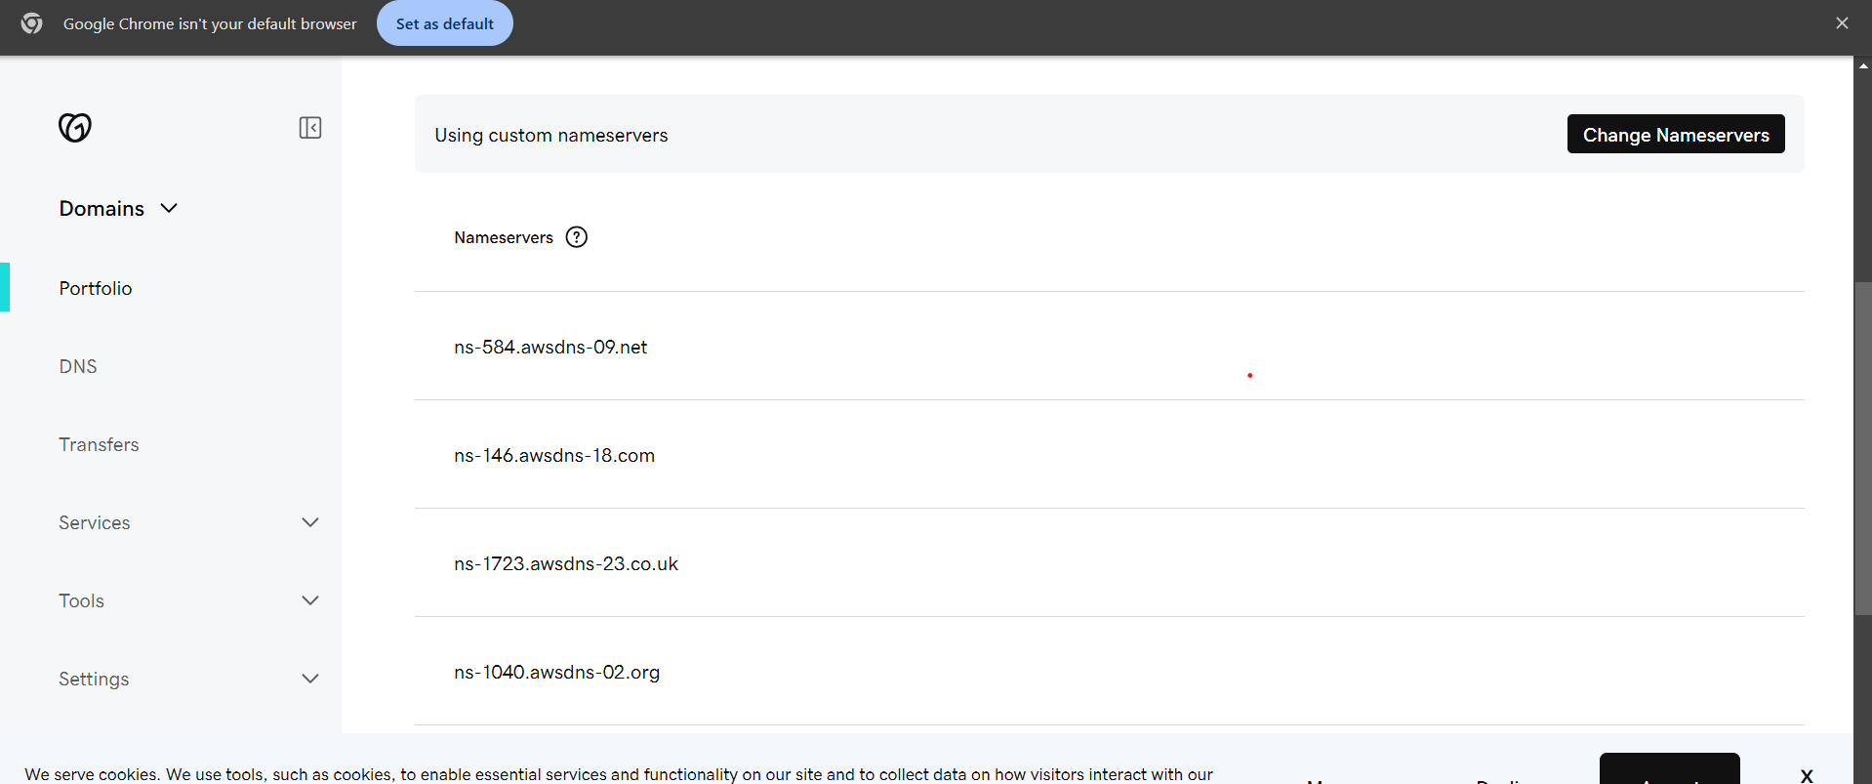

---browse with your domain name

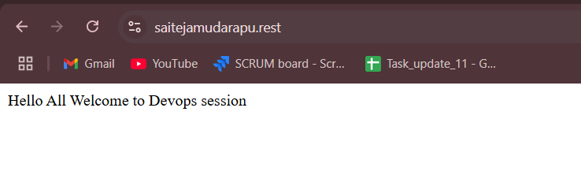

1. Update the index.html in s3 bucket and the updated file should be accessible by using domain name

----- i have update index.html file and uploaded and provided public permissions

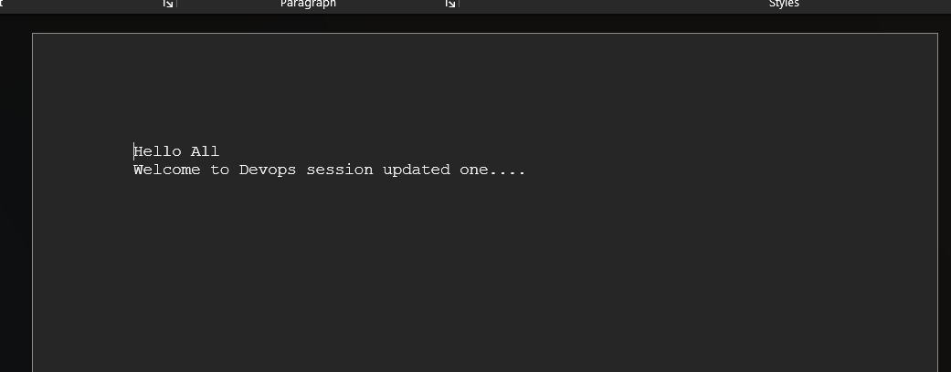

----- if i browse with my domain name we find the updated one

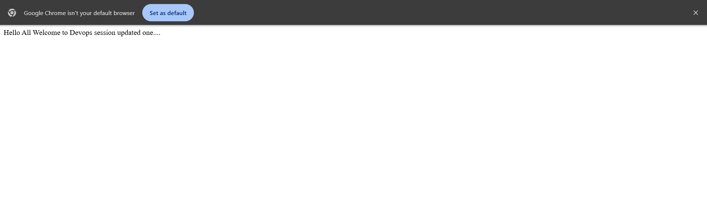

7) Share the Domain name in slack to test the connectivity.

Domain name – https://saitejamudarapu.rest